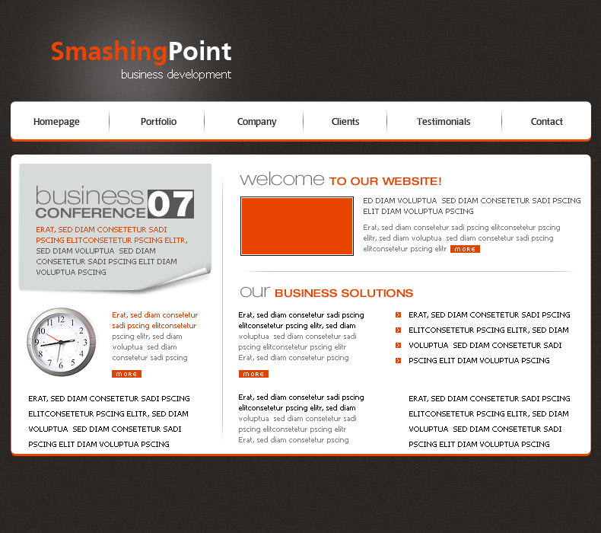
Create a new document
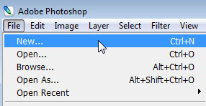
Please use the following settings:
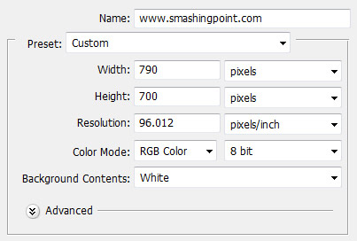
Set the foreground color to : #2b2724
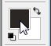
Select The Paint Bucket Tool, and press on time on your canvas.
Select The background layer
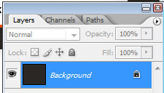
Press on CTRL+J ( this shortcut will duplicate the selected layer )
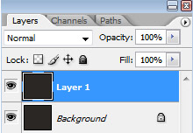
Select ” layer 1 ” and go to Filter > Noise > Add Noise
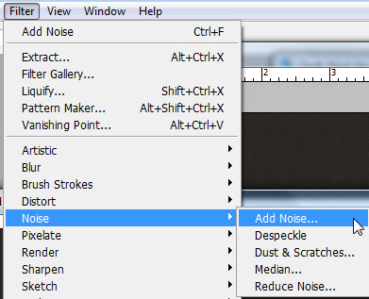
Then use the following settings:
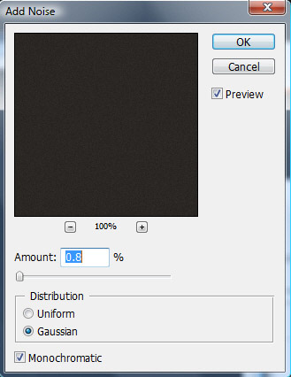
Select Rounded Rectangle Tool, and on the top of your screen, set the following settings
On your layout create two shapes for our navigation. I will change my foreground color to #e84502 , then i will use Rounded Rectangle Tool
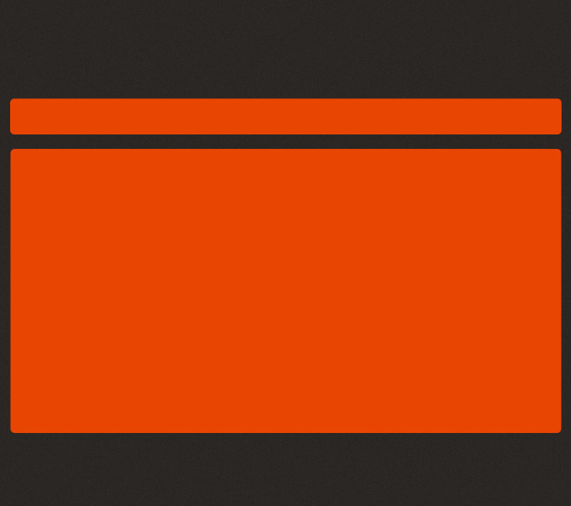
Duplicate these 2 orange shapes. To duplicate the layer, first you need to select it, then press on CTRL+J
After you will duplicate the orange shapes, change the colors to white. To change the color you need to double click on the layer thumbnail, then you can chose the white color
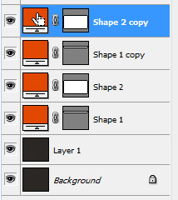
this is what i have so far
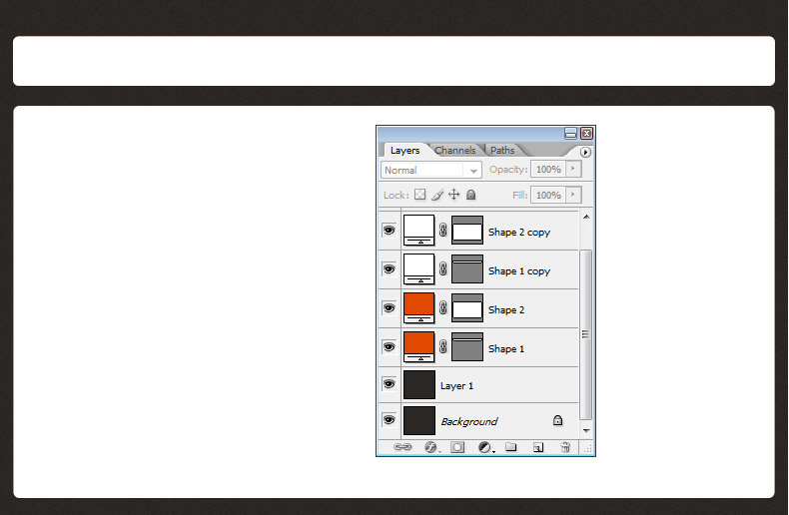
Now i will select the Move Tool ( V ) , and i will move the white shapes to the top of the layout
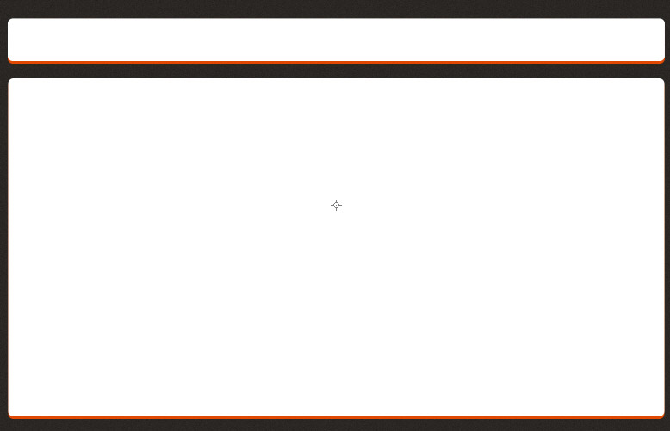
I will place some stock images on my layout
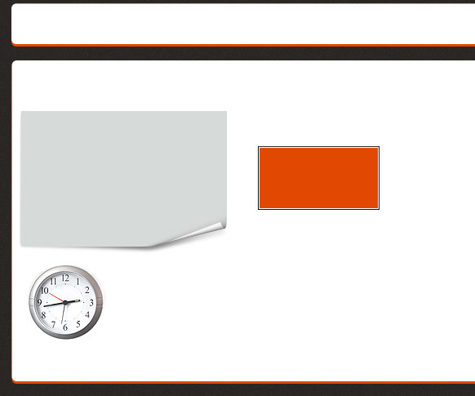
With Type tool, i will add some text
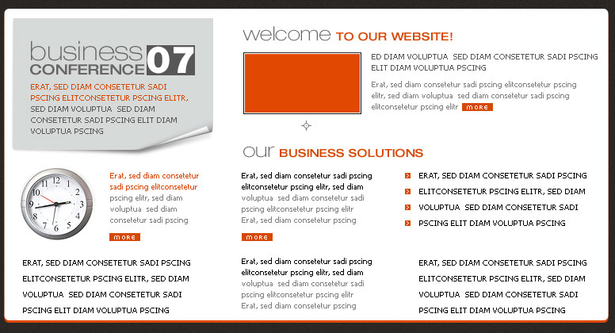
With the same tool, add another text on the navigation bar
Select Line tool, and be sure you set the line Weight to 1 px
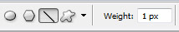
Create a vertical line between the navigation buttons
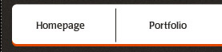
Now it is very important to rasterize the layer. to do this you need to right click the layer in your layer palette
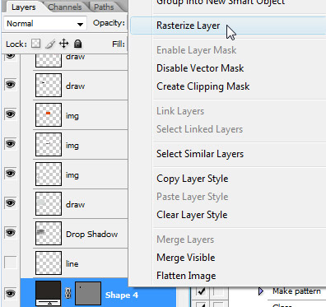
Select Eraser tool, and change your brush to 60 Soft Mechanical 60 pixels
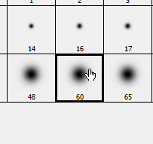
And try to delete the top and the bottom part of the line
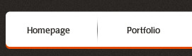
Duplicate this layer ( to duplicate you need to have the layer selected, then press on CTRL+J )
Select Move tool, and place the duplicated line on the right side between the other text buttons
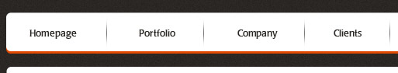
On the top of our layout, i will create a simple text logo. in my future tutorials i will show you how to create great looking logos

Create a new layer right above the layer 1
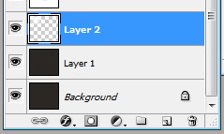
Select Brush tool ( change the brush to Soft Mechanical 60 pixels ), and with white color make a simple dot, under the text logo

To create a nice effect, please reduce the opacity for this layer to 25 %
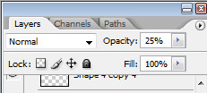
This is my result


